**PLANT DISEASE DETECTION USING IMAGE PROCESSING AND MACHINE LEARNING**

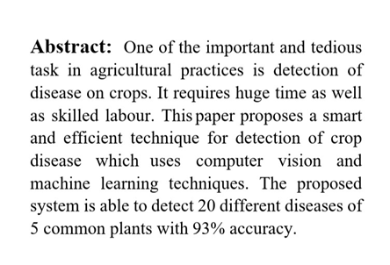

**Coding :**

**test.py**

# Import the required libraries

import numpy as np

import matplotlib.pyplot as plt

import cv2

# Load the image

image = cv2.imread('img.jpg')

# Convert the image to grayscale

gray_image = cv2.cvtColor(image, cv2.COLOR_BGR2GRAY)

# Convert the image to HSV format

hsv_image = cv2.cvtColor(image, cv2.COLOR_BGR2HSV)

# Plot the grayscale image

plt.subplot(1, 2, 1)

plt.imshow(gray_image, cmap='gray')

plt.title('Grayscale Image')

# Plot the HSV image

plt.subplot(1, 2, 2)

plt.imshow(cv2.cvtColor(hsv_image, cv2.COLOR_HSV2BGR))

plt.title('HSV Image')

plt.show()

**Input :**

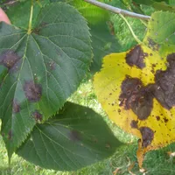

**Run in Commond Prompt:**

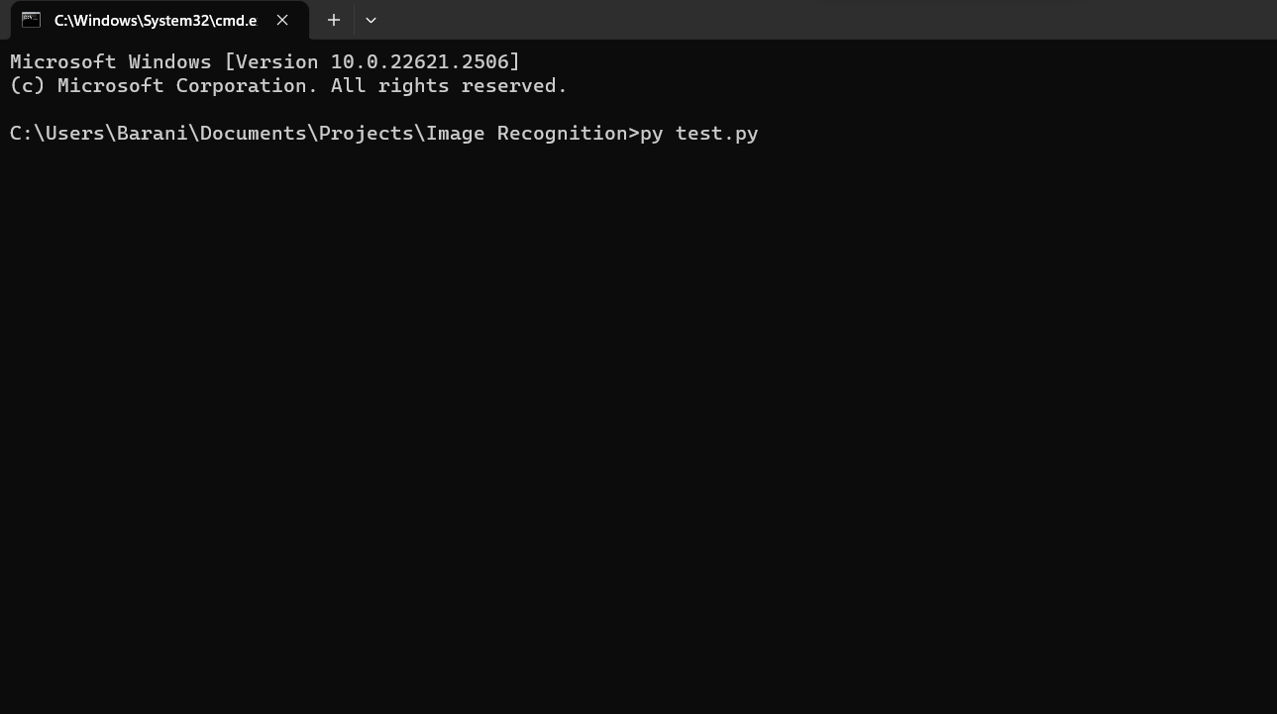

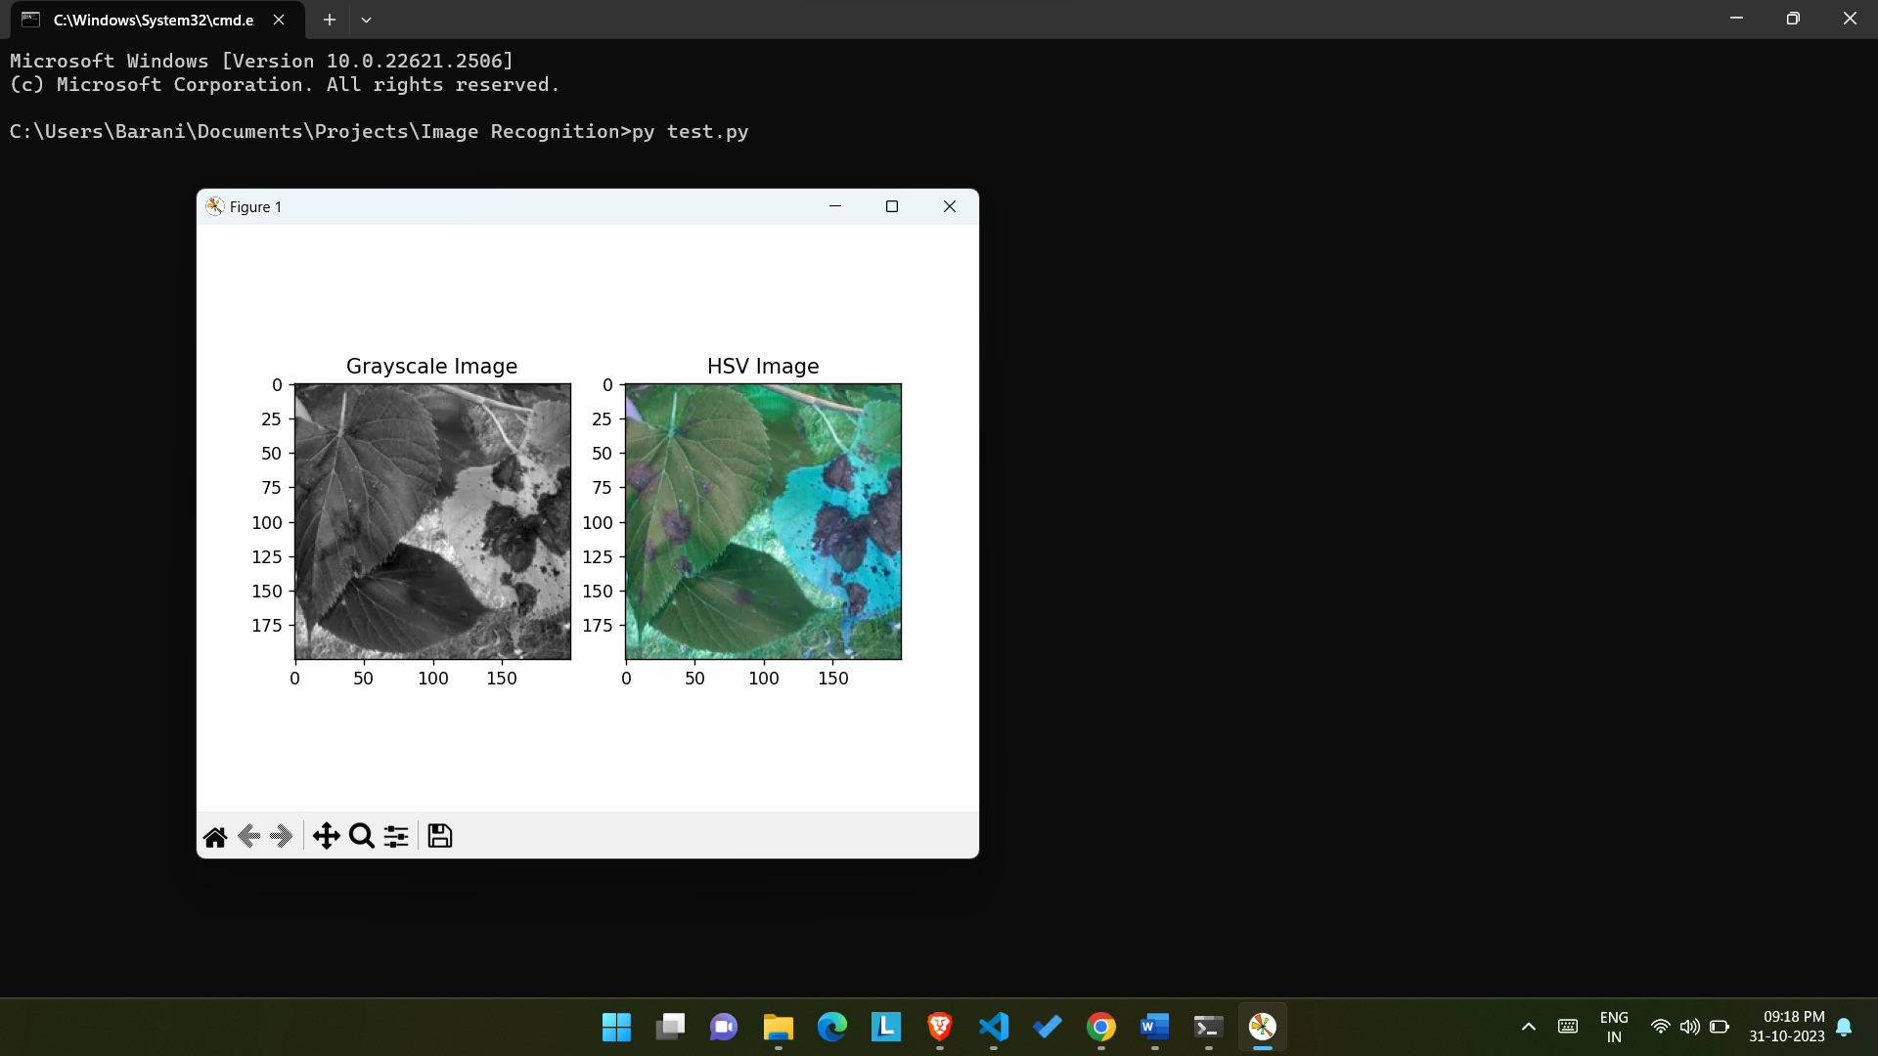

The Out Put Should indicates the Diseased Lead Below Picture,

